**IDEAL GIRLS’ HIGH SCHOOL**

**END OF TERM 1 ASSESSMENT 2024**

GEOGRAPHY

**Paper 1**

**273/1**

2 hours 45 minutes

**INSTRUCTIONS TO CANDIDATES:**

*This paper consists of* **two** *sections;* **A** *and* **B***. It has* **six** *examination items.*

*Section* **A** *has* **two** *compulsory items.*

*Section* **B** *has* **two** *parts;* **I** *and* **II**. *Answer* **one** *item from each part.*

*Answer* **four** *examination items in* **all**.

*You may use diagrams where applicable to illustrate your answers.*

*Any additional item(s) answered will* **not** *be scored.*

**SECTION A:**

**MAP AND PHOTOGRAPH SKILLS**

Answer **All** items in this section

**Item 1:** MAP SKILLS (Compulsory)

For this item use the East Africa 1:50,000 (Uganda) map extract of Lake Nakivali series Y732, sheet 86/4, Edition 4 – U.S.D, the information in the text below and the support materials below to answer the tasks given.

1. Determine the grid reference of Nyabeya. (01score)
2. Mention the man – made feature found at grid reference 727051. (01 score)
3. i) Ainembabazi lives in musirira in central parts of the area near the Lake as shown on the map extract. Whenever she wants to travel, she picks abodaboda from the road Junction at grid reference (610082). She wants to visit her friend, who stays at Rugaga road and the boda guy charges her 1,000shs per Kilometer.

**Task:**

Determine the amount of money she will spend on the Journey. (05 score)

ii) She also intends to tour L. Nakivali one day but has very little knowledge about how large it is. Help Aine to determine the area covered by L.Nakivali. (07 scores)

1. Ainembabazi schools from Zuru, grid reference (693093) and attends church service on Sundays at Nyamiyaga church grid reference (727051). Help her determine;
2. Direction in which she will move from the church to school. (01score)
3. Bearing of the church from the school she studies in Zuru. (01 score)
4. With evidence from the area shown on the map, suggest three economic activities that can be carried out. (04 score)

**Item 2**: PHOTO GRAPH SKILLS (Compulsory)

**Study the image below and answer the tasks that follow**:

Lake Bunyonyi is found in Kabale, a district in South Western Uganda. It is surrounded by a hilly terraced land scape which provided a scenic beauty to the sub region that has attracted many tourists to the area.

**Support Material**

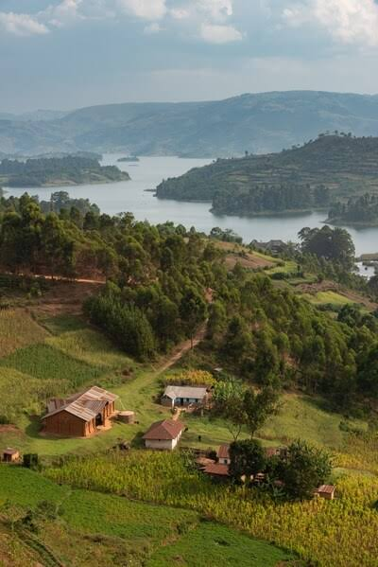

**Task**

1. Draw a land scape sketch of the area shown in the support material and on it mark and name:
2. The lake, bays and headlands
3. Hilly land scape
4. The forest and settlement. (07mrks)
5. i)Explain four reasons why you would recommend a tourist coming to East Africa to visit the area shown in the photograph. (04scores)

ii)Namusosa Anna a S.4 student of Ideal Girls High School told class mates that her parents are planning to migrate from this area in the photograph (Kabale) very soon. In four (4) statements, support the decision of Namusosa’s parents. (04scores)

1. Describe the process responsible for the formation of either a Lake or a mountain in the photograph. (05 scores)

**SECTION B**

This section has part **I** and part **II**

**Part I**

Answer one item from this part.

**Item 3:** Study the table below showing data delivered from one of the weather stations on the shores of Lake Victoria and answer the questions that follow:

|  |  |  |  |  |  |  |  |  |  |  |  |  |
| --- | --- | --- | --- | --- | --- | --- | --- | --- | --- | --- | --- | --- |
| **Month** | **J** | **F** | **M** | **A** | **M** | **J** | **J** | **A** | **S** | **O** | **N** | **D** |
| Temp(⁰c) | 20 | 21 | 22 | 22 | 21 | 20 | 20 | 21 | 22 | 22 | 21 | 20 |
| Rainfall (mm) | 30 | 40 | 128 | 195 | 190 | 40 | 54 | 98 | 130 | 218 | 145 | 37 |

**Task**

a)Using the graph paper provided, neatly draw a climate graph to portray the above data. (10mrks)

b)A group of local farmers in the area where the station is found have just received funds from the government under the Parish Development Model (PDM) scheme. They wish to carry out a farming project of growing crops. Among the activities they are expected to do are; clearing the land, ploughing, preparation of seeds, planting, spraying and weeding. As some body who has learnt and understood the influence of climate on human activities, design a farm calendar to help these local farmers plan, coordinate and effectively carryout farming activities through the year. (04 score)

1. In your analysis, prove that you cannot support your friend to settle in such an area where this station is located. (03 score)
2. From the above table determine the following;
3. Annual Range of Temperature (01 score)
4. Annual Rainfall (01 score)
5. Annual Temperature (01 score)

**Item 4**: Households in Uganda derive their energy from firewood and charcoal. According to the World Bank, the total demand for wood fuel is estimated to have increased by 9.1% between 2015 – 2019. This has translated into massive acres of forests and wood lands being cleared for firewood and charcoal leading to climate change. (Source: The New Vision News Paper: Feb, 19th,2023) .You have been appointed as a national programme officer for NEMA, write an article of about 100 words on the advices you will make to the Ministry of Environment to change the trend of the forest cover destruction. (20 score)

**Part II**

**Answer one item from this part**

**Item 5:** You have watched on television that Katonga River in May, 2023 flooded over the area around and it affected many people’s lives and their propert.

**Support material**

**a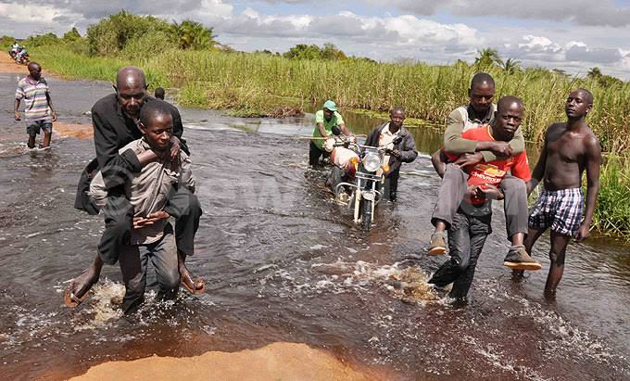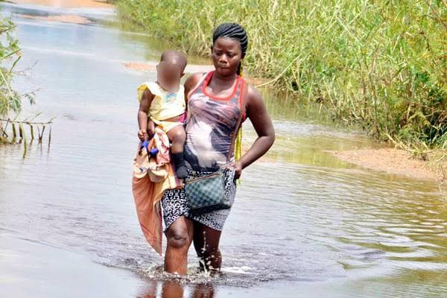b**

**Task**

Write a letter to the ministry of disaster preparedness and refugees in Uganda advising them on what can be done before another disaster strikes people dead. In your letter indicate the census of floods, their effects and possible solutions. (20 score)

**Item 6:** Uganda is yet to conduct a population census in May of 2024. This is according to the Uganda Bureau of Statistics (UBOS). The ministry of finance, planning and economic development is responsible for the supervision of the agency. It matters to be counted as the slogan goes for the Agency. People have been increasing over the past years and this has awaken the government to its duties and responsibilities.

**Support material**

Study the table to answer the tasks that follow

|  |  |
| --- | --- |
| **Region** | **Population (million)** |
| Northern | 4.8 |
| Eastern | 10.6 |
| Western | 11.1 |
| Central | 20.5 |

(Source: Uganda Bureau of Statistics)

**Task**

1. Assume you are amongst the Enumerators to conduct a census in parts of Uganda, draw a divided circle or a pie – chart to illustrate the above data.(10mrks)
2. In your analysis as a national citizen, what do you think is responsible for population increase in Uganda? (05 score)
3. From the table above, determine the region with the; (i) Highest population

(ii) Lowest population

1. What are some of the bad impacts of people being many in the society? (03mrks)

**END**